**RESUME**

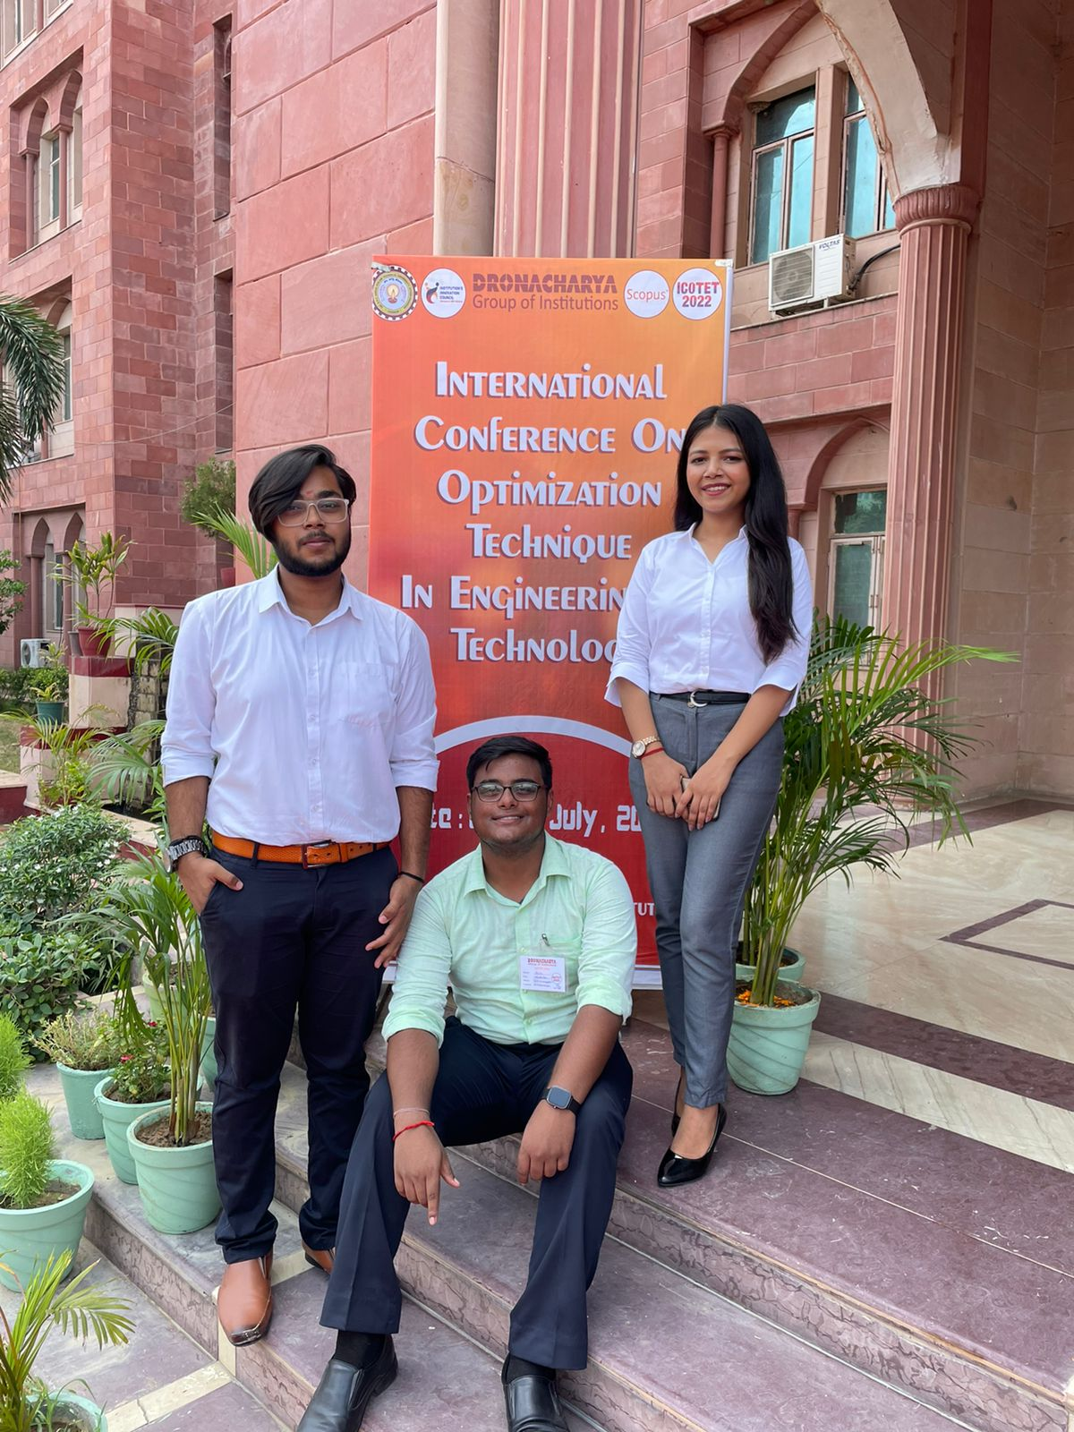

**KUSHAGRA SINGH**

**Address**:- H no. 1301, flat no. 303, Laxman Vihar Phase 2, Gurugram, Haryana

**Mail ID**: - kushagrasinghonline@gmail.com

**Contact No**. – 8377851895

**Career Objective**

To be the part of an enthusiastic work environment, where I can use my technical skills to accomplish organizational goals.

**Academic Background**

Pursuing B.Tech in Computer Science Engineering from Dronacharya College Of Engineering, Gurugram, Approved By AICTE.

|  |  |  |  |
| --- | --- | --- | --- |
| **Institute / University** | **Degree/ Examination** | **Percentage** | **Year** |
| Dronacharya College of Engineering | B.Tech | Pursuing(1st Year) | ----- |
| Kendriya Vidyalaya AFS 1 ggn | 12th | 80% | 2021 |
| Kendriya Vidyalaya AFS 1 ggn | 10th | 80% | 2019 |

**Technical Skills**

* Languages Known: - HTML, CSS, C and currently started learning C++ and Dsa.
* Operating Systems:- Microsoft Windows XP/Vista, Windows 10, Windows 11,MacOs.

**Certifications And Memberships**

* I am a 5-star coder at Hackerrank in C Language.
* I have completed certification module 1 in c (programming fundamentals) from Coursera.
* I have completed certification module 2 in c (structured programming) from Coursera.
* Qualified and secured AIR 20 in National Creativity and Aptitude Test(2022).

**Workshops And Technical Events**

* Attended Drone Workshop at Dronacharya College Of Engineering in December 2021.
* Organising team member of Techpreksha 2022 organized by GFG.

**Achievements**

* Published a research paper on Artificial intelligence
* Presented my review paper in ICOTET at Dronacharya Group of Institute.

**Strengths**

* Leadership Qualities
* The ability to work in a controlled environment.
* Hard-Working with lots of Patience.

**Extracurricular Activities**

* ESPORTS Player
* Fond Of Music
* Dancing